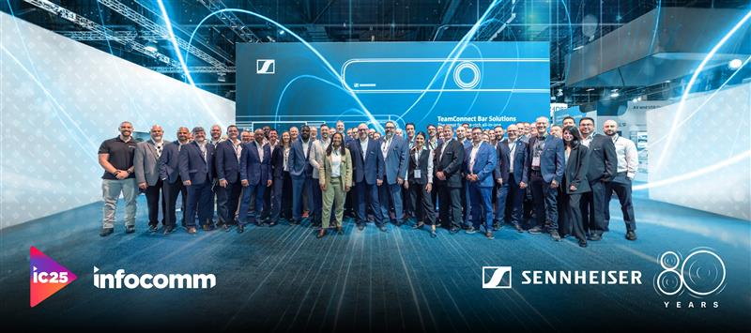
Sennheiser to Showcase Collaboration and Wireless Audio Solutions at InfoComm 2025
Lineup to include TeamConnect family of products, as well as wireless solutions Spectera and EW-DX, as company kicks off its 80 Years anniversary in Orlando

Orlando, Fla. June 4, 2025 — Sennheiser, the first choice for advanced audio technology that makes collaboration and learning easier, is gearing up to present its cutting-edge professional AV solutions at InfoComm 2025 in Orlando from June 7-13. On booth 3401 at the Orange County Convention Center, Sennheiser will invite attendees to explore the advancements in the company’s latest education, collaboration and wireless solutions. Featured highlights will include highly anticipated product development news impacting AV and IT teams, such as the newest additions to the TeamConnect (TC) family of products available for demo. Spectera, the world’s first wideband, bidirectional wireless ecosystem, will also be on display at this year’s show. Rounding out the experience are demos of SoundBase, a brand-neutral, collaborative RF coordination tool.

“We’re thrilled to once again connect with our partners and customers at InfoComm 2025, and equally excited to demonstrate how our current innovations are setting the groundwork for the future of AV,” says Jeffrey Horan, Global PR/Marketing Manager, Business Communications, Sennheiser. “Attendees will have access to live demonstrations and hands on experiences with our innovative audio solutions, plus hear some exciting product development news for AV and IT teams. We also encourage showgoers to participate in our partner scavenger hunt for a chance to win some great prizes.”

The TeamConnect family will be on display at InfoComm, including the TC Ceiling Medium (TCC M) with its new ceiling tile installation variant, launched earlier this year. The TCC M Ceiling Tile (CT) offers an even simpler integration of TCC M into suspended grid ceilings, significantly reducing installation time and costs. Available in both 60 cm square and a 2 ft square (primarily for the US market) solutions, the TCC M CT blends seamlessly into any environment. The TCC M CT will be available as an assembled kit, with the front plate also available as an accessory for retrofit installations. Visitors to the booth will also be able to witness the award-winning TC Bar Solutions and TCC M in action in dedicated live demonstration rooms.

Revolutionary Wireless Audio
Sennheiser will showcase Spectera, the world’s first wideband, bidirectional wireless ecosystem. Now shipping, attendees can experience the unprecedented ease of use this solution offers for wireless mics, IEMs, and control data within a single RF channel and bodypack. Spectera’s small footprint, automatic coordination, and simplified setup redefine live audio productions. The ecosystem includes the Base Station, bidirectional SEK bodypacks, DAD transceiving antennas, optional MADI cards, intuitive LinkDesk software for larger Spectera setups and the streamlined Spectera WebUI for monitoring and controlling an individual Base Station.

InfoComm guests will also have the opportunity to see demos of the brand-neutral SoundBase app. The RF coordination software is compatible with systems from various wireless brands and unifies the wireless audio workflow into a single, simple, and flexible platform.

Also on display will be EW-DX, the latest addition to Sennheiser’s Evolution Wireless Digital family. Designed for ease of use without compromising power and flexibility, EW-DX is suitable for a wide range of business and professional applications, with straightforward installation and integration that allows for seamless scalability across existing Dante networks, from intimate meeting rooms to large campus deployments.

Alesia Hendley on AI and More
Sennheiser’s Alesia Hendley, Business Development Manager, will participate in the panel discussion “Innovative Event Design: Real-World AI and Virtual Production Insights” on Wednesday, June 11th, from 9:30-10:30 a.m. at Booth 4327. Attendees will gain valuable insights into the evolving landscape of event experiences through real-world case studies and solutions. A brief networking mixer will follow the panel.

Great Partners, Great Prizes
Sennheiser’s Perfect Pair Partner Hunt returns to InfoComm, offering attendees a fun and interactive way to discover how Sennheiser technology connects with solutions from across the AV ecosystem.

Participants can join the hunt by following these simple steps:
1. Download the Scavify app to a mobile device.
2. Search for “IC25” to join the hunt.
3. Complete tasks at participating partner booths—such as scanning QR codes, joining live demos, or capturing photos—to earn points.

Each task completed increases the chance of winning a selection of exclusive prizes contributed by Sennheiser and its partners. A free pair of Sennheiser socks is also available to all participants at booth 3401.

This year’s hunt is supported by 26 alliance and technology partners, including:
Airtame, Audac (AC Americas), Audinate, AVer, Barco, Crestron, Datavideo, Heckler, Kramer, Laia, Lenovo, Lightware, Lumens, Marshall Furniture, MAXHUB, Modus VR, Q-SYS, Sharp, Sound Control Technology, Symetrix, Utelogy, Valens, Vaddio, ViewSonic, Xilica, and Zoom.

In addition, visitors can explore Sennheiser’s interactive touchscreen display at booth 3401, offering a quick and engaging way to see how Sennheiser products connect with partner technologies to support seamless, integrated AV experiences.

For more information about the Perfect Pair Partner Hunt, visit https://mautic.sennheiser.com/infocomm-perfectpair-2025

Free exhibition hall passes can be booked using the code SEN432 at infocommshow.org.
More information about Sennheiser at InfoComm can be found here.

About the Sennheiser Brand – 80 Years of Building the Future of Audio
We live and breathe audio. We are driven by the passion to create audio solutions that make a difference. This passion has taken us from the world’s greatest stages to the quietest listening rooms – and made Sennheiser the name behind audio that doesn’t just sound good: It feels true. In 2025, the Sennheiser brand celebrates its 80th anniversary. Since 1945, we stand for building the future of audio and bringing remarkable sound experiences to our customers. While professional audio solutions such as microphones, meeting solutions, streaming technologies and monitoring systems are part of the business of Sennheiser electronic SE & Co. KG, the business with consumer devices such as headphones, soundbars and speech-enhanced hearables is operated by Sonova Holding AG under the license of Sennheiser.

www.sennheiser.com
www.sennheiser-hearing.com

Local Press Contact
InGear
Peter Schuyler
peter@ingearpr.com
+1 917-496-8970

Global Contact
Jeffrey Horan
Global PR/Media Manager Business Communication
jeffrey.horan@sennheiser.com
+1 860-598-7539

